Cancel Expense Report
1. From the Workday Landing Page, search for and select Find Expense Reports.

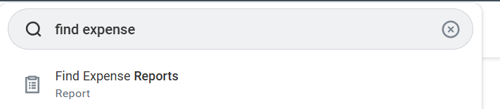
2. Use the Menu to enter the name of company: SNC and Created by Worker. Select OK.

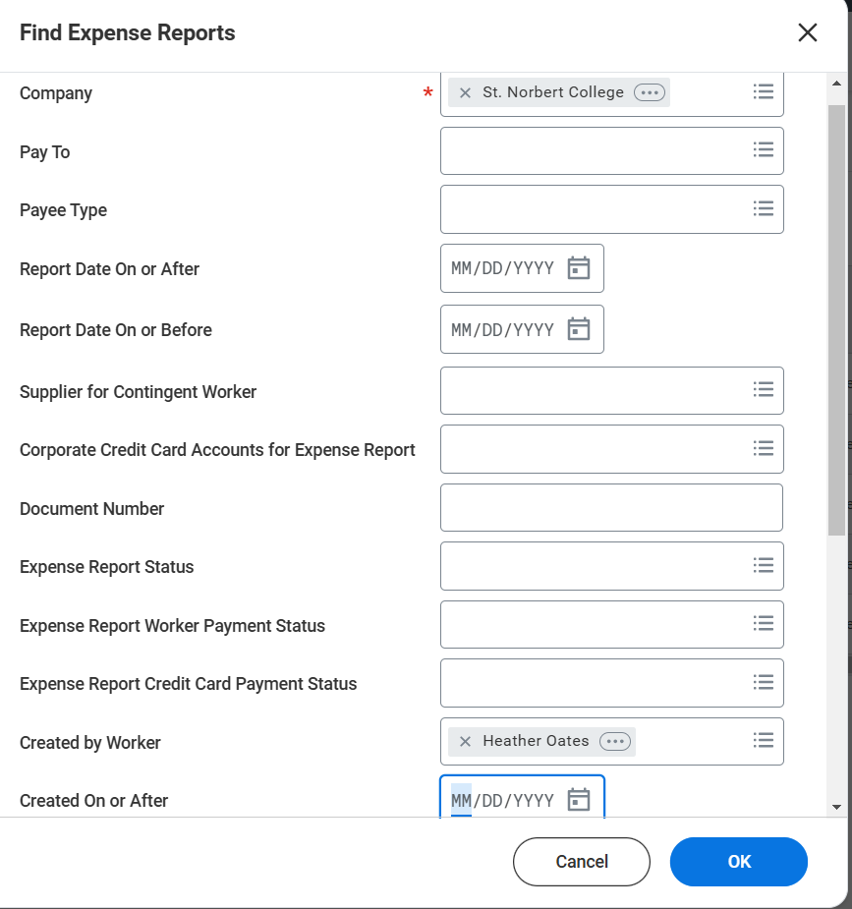
- Click the 3 dots that will appear when you hover at the end of the Expense Report Number.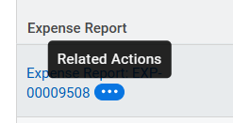
4. Hover over Expense Report and select Cancel.
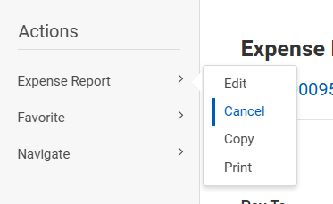

- Select Ok on Cancel Expense Report Page.

